For this assignment, you will solve problems based on what you have learned in: Inheritance and Polymorphism.
Instructions

- Review the chapters from the book and class notes.
- There are 2 questions in this assignment.

Due Date and Time: September 18, 2019, in class.

Submitting this Assignment

You do not have to submit this assignment. When you have completed solving all questions, show them to the Instructor.

Grading Criteria

There are no marks to this assignment.

- Design the class Circle, and Class Cylinder, as shown in the figure. Write a test program (says TestCylinder) to test the Cylinder class created.

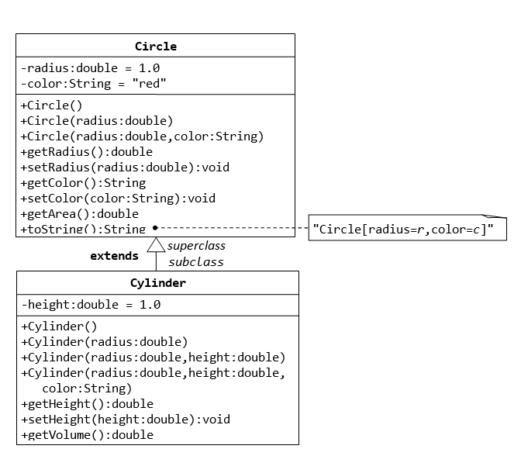
Also, Override the toString method in Cylinder class to display the properties of Cylinder.

2. Create the two packages p1 and p2 ,and Design the classes C1, C2, C3, C4 and C5 as shown in figure. Write the test program to understand the visibility of all the access modifiers.

